Science Fair Display Board: DUE Thursday January 26
How to Set Up Your Science Board

Maximum Size of Project
Depth (front to back): 30 inches or 76 centimeters
Width (side to side): 48 inches or 122 centimeters
Height (floor to top): 108 inches or 274 centimeters

For almost every science fair project, you need to prepare a display board to communicate your work to others. In most cases you will use a standard, three-panel display board that unfolds to be 36" tall by 48" wide.
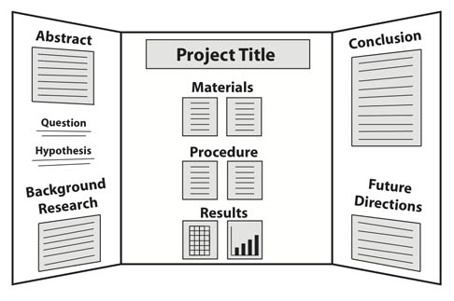
EXAMPLE OF SCIENCE FAIR DISPLAY BOARD

- Organize your information like a newspaper so that your audience can quickly follow the thread of your experiment by reading from top to bottom, then left to right. Include each step of your science fair project: Abstract, question, hypothesis, variables, background research, and so on.
Introduction
References
DISCUSSION
The folding and combination of polypeptide chains forms the specific, three dimensional shape of an enzyme. This shape is extremely important to the enzyme's catalyzing efficiency and many environmental conditions can affect the shape of enzymes and thus their efficiency. A range of pH values exists for all enzymes, between which they reach their maximum catalyzing action. This range is usually between a pH of 6-8. pH levels outside this range can denature the enzyme, thereby decreasing its catalyzing ability.
- Use a font size of at least 16 points for the text on your display board, so that it is easy to read from a few feet away. It's OK to use slightly smaller fonts for captions on picture and tables.
This sample shows how difficult it can be to read text when you print it on top of an image. Don't do it!
- The title should be big and easily read from across the room. Choose one that accurately describes your work, but also grabs peoples' attention.
- A picture speaks a thousand words! Use photos or draw diagrams to present non-numerical data, to propose models that explain your results, or just to show your experimental setup. But, don't put text on top of photographs or images. It can be very difficult to read.
Materials and Construction Techniques
• The standard presentation boards are self-standing and work quite well. Display boards in black or white-colored "foam core" (a sandwich made up of two pieces of cardboard with plastic foam in the middle) or corrugated cardboard are readily available at most office supply stores (Staples, Office Depot, Office Max) for $6 to $12. Of course, you can also make your own for free from a large cardboard box.
• Print out your information on white paper that you will attach to your display board. Be sure to proofread each sheet before you attach it.
• Glue sticks (use plenty) work well for attaching sheets of paper to your display board. Use double-sided tape for items like photographs that may not stick to glue. Use glue sticks for attaching paper to your board. Adhesive squares are good for attaching photographs.
• Tip: Instead of regular paper, use cover stock (67#) or card stock (110#). These heavier papers will wrinkle less when you attach it to your display board, especially if you use a glue stick. Matte paper is preferable to glossy because it won't show as much glare— glare makes your display board difficult to read.
• Use color construction paper to add accents to your display board. A common technique is to put sheets of construction paper behind the white paper containing your text.
SCIENCE FAIR DISPLAY BOARD RUBRIC
Basis for Grade | Points Available | Points Earned
Typical, tri-fold display board used | 5
Includes all required components (Title, Abstract, Introduction, Hypothesis, Materials, Procedures, Results/ Analysis, (including table, chart, or graph), and Conclusion. | 5
Text, graphs, illustrations, charts, tables, pictures, etc. are well-organized and neatly displayed on board. Information is placed in appropriate sections under the correct headings and in the correct locations as per Science Fair instruction picture (see above) | 5
All information is typed, not written and fonts for titles and for text are large enough to be read from 4 feet away per instructions | 5
Creativity is evident | 10
Information conveyed on display board provides the reader with a clear overview of the project | 15
Grammar / spelling is correct | 5
TOTAL | 50

